Advance Systems Project
Hotel Management System Application
Big Data Analytics
Jahnavi Venna
700756869
University of Central Missouri

ABSTRACT

The rapid growth of technology has transformed the hospitality industry. It offers new ways to improve customer service, increase efficiency, and simplify hotel management tasks. The Hotel Management System is designed to update the daily operations of a hotel or restaurant.

It provides a unified system for managing customer orders, kitchen tasks, and overall restaurant management. Traditionally, these operations have been done manually. This often leads to inefficiencies, mistakes, and communication issues among staff.

The Hotel Management System aims to address these problems with an easy-to-use, role-based system that promotes smooth interactions among customers, managers, and chefs, ensuring a seamless experience for everyone involved.

This project presents a web-based Hotel Management System that supports three main roles: Customer, Manager, and Chef. Each role has unique features to simplify order placement, menu management, kitchen coordination, and real-time data tracking. The system aims to improve both the user experience for customers and the workflow for staff.

Customers can easily browse the menu, place orders, and make payments. Managers can oversee operations, manage the menu, assign chefs to orders, and track real-time data on popular items and kitchen workloads. Chefs receive an efficient dashboard to manage their assigned orders and update their statuses.

Key features of the system include role-based access, where each user (customer, manager, chef) can access specific functions based on their roles. Real-time analytics provide managers with insights into popular menu items, the busiest chefs, and the current workload in the kitchen, helping ensure smooth operations. Order management allows customers to place orders and track their progress.

Payment processing offers a secure way for customers to pay for their orders directly through the system. Additionally, customers can view their order history, making it easy to keep track of past purchases.

The system has a modular design, with each role tied to specific functions that boost the overall efficiency of restaurant or hotel operations. The Customer Module enables browsing, ordering, and payment. The Manager Module offers tools for menu management, order assignments, and access to real-time data. The Chef Module makes kitchen tasks easier by allowing chefs to see assigned orders and update their status in real time.

By using this Hotel Management System, restaurants and hotels can improve staff coordination, cut down on operational delays, and enhance the overall customer experience. The system ensures that all users can perform their tasks more effectively and interact with the system in ways that suit their roles.

In summary, the Hotel Management System tackles key issues in restaurant and hotel operations, providing an integrated, user-friendly solution to streamline tasks and boost customer satisfaction.
Table of Contents
ABSTRACT 2
Project Title: Hotel Management System 6
Purpose of the project 6
Problems in Existing system 7
How the Hotel Management System Solves These Problems 9
Solutions to these problems 10
System Analysis 12
Benefits of the Agile Model 15
Introduction 16
Customer Module 16
Manager Module 17
Chef Module 18
System Features 19
Real-Time Analytics Dashboard 19
Functionalities 20
Manager Functionalities 20
Chef Functionalities 21
Customer Functionalities 21
Landing Page (Customer) 22
Landing Page (Manager) 22
Landing Page (Chef) 23
Software/Hardware requirement Requirements 23
Technologies Used 23
Frontend Tchnologies 24
Backend Technologies 25
Database Technologies 26
Messaging and Streaming (Kafka) 27
Development Tools 31
System Design 31
Purpose of System Design 32
System Architecture 32
Core Modules for Each Role 33
System Workflow 34
Security and Authentication 34
Real-Time Features 35
Scalability and Extensibility 35
Use Case/Sequence Diagrams 36
Customer Role 36
Manager Role 36
Chef Role 37
ER Diagram 38
Class/UML Diagram 39
Data Flow Diagram 40
Level 0 DFD 40
Level 1 DFD 41
Level 2 DFD 42
Web Pages 43
Home Page 43
Login Screen 43
Register Screen 44
Customer Screens 44
Manager Screens 50
Chef Screens 53
Conclusion 55

Project Title: Hotel Management System
Purpose of the Project: Hotel Management System
The primary purpose of the Hotel Management System is to design and implement an integrated, web-based platform that simplifies and automates the day-to-day operations of a hotel or restaurant. The system aims to provide a centralized solution where customers, managers, and chefs can seamlessly interact and perform their respective roles to ensure smooth hotel or restaurant management.
This project addresses key challenges prevalent in traditional hotel management systems, such as inefficient order handling, lack of integration between the kitchen staff and management, and poor real-time data tracking. By developing a robust system that unifies all roles—customers, managers, and chefs—under one platform, the project aims to reduce administrative overhead, streamline operations, improve customer service, and ensure better decision-making.
Additionally, the system is designed to enhance communication and coordination between customers, managers, and chefs. It automates tasks like order placement, payment processing, and order tracking, making the process faster and more reliable. Managers can monitor real-time analytics, such as the busiest chefs and most popular menu items, which helps in optimizing kitchen performance and inventory management. Chefs receive clear and updated instructions, reducing errors and improving kitchen operations.
The Hotel Management System also ensures that data security and integrity are maintained throughout the application. By using modern web technologies and secure role-based access control, the system offers a safe environment for handling sensitive customer and operational data.
Ultimately, the purpose of this project is not just to create a software application, but to develop a tool that simplifies hotel and restaurant operations, improves the customer experience, and contributes to the efficient management of hotel resources and services.
Problems in the Existing System
- Manual Order and Menu Management: Traditional systems rely on paper-based or non-integrated methods for managing orders and menus, leading to inefficiencies, errors in order handling, and delays in updating the menu.
- Lack of Integration Between Customers, Managers, and Chefs: In many hotels and restaurants, customers place orders manually or through multiple intermediaries, leading to miscommunication and slow processing. Managers may not have real-time visibility into kitchen performance, and chefs may not receive immediate updates on order status.
- Inefficient Order Handling: Orders are often handled manually, making it difficult to track, retrieve, or validate them, especially when multiple staff members are involved in the process. This can result in delays, mistakes, or unsatisfied customers.
- No Real-Time Analytics or Performance Tracking: Managers often lack access to key metrics, such as most ordered items, kitchen load, or chef performance. Without this data, it is difficult to make informed decisions about staffing, menu changes, or inventory management.
- Lack of Seamless Communication Between Roles: In traditional hotel management systems, communication between customers, managers, and chefs is often fragmented, which can lead to misunderstandings or slow service delivery. For example, chefs may not be aware of a customer's special-order requests, or managers may not be able to quickly assign tasks to chefs.
- Limited Access to Order History: Customers, managers, and chefs may have limited access to past order data, making it difficult to track repeat orders, customer preferences, or historical performance metrics.
- Security and Privacy Concerns: Traditional systems may not have secure authentication and access controls, potentially allowing unauthorized users to manipulate sensitive customer or operational data.
- Manual Payment Processing: Payments are often handled manually or offline, leading to inefficiencies, errors in billing, and delays in order fulfillment. The lack of integrated payment processing can create friction in the customer experience.
- Cumbersome Staff Scheduling: Traditional systems may lack efficient tools for managing kitchen staff schedules, leading to under or over-staffing during peak hours and affecting the quality of service.
- Inconsistent User Profiles: Customers, managers, and chefs often have to maintain separate profiles or accounts across different systems, leading to redundant data and inconsistent information, which can result in errors or confusion.
- Limited Reporting and Analytics: Existing systems may lack tools for generating comprehensive reports, tracking system performance, or analyzing customer behavior and preferences. Without such insights, making data-driven decisions becomes difficult.
- Manual Inventory Management: For restaurants and hotels that manage inventory (e.g., food, beverages, supplies), many systems still rely on manual inventory tracking, which can lead to stock mismatches, missed orders, and inefficient supply chain management.
How the Hotel Management System Solves These Problems
- Automation of Order Placement and Management: The system automates order placement, processing, and tracking, reducing errors and improving speed.
- Role-Based Access and Integration: Managers, customers, and chefs interact within a unified platform, ensuring smooth communication and real-time data synchronization.
- Real-Time Analytics and Reporting: Managers can access a real-time analytics dashboard that tracks key performance metrics like popular menu items, kitchen load, and chef performance.
- Seamless Payment Integration: The system integrates secure payment processing, allowing customers to pay for their orders seamlessly and securely.
- Real-Time Order Tracking: Customers can track the status of their orders, and chefs can update the progress of orders, ensuring everyone is on the same page.
- Improved Staff Management: Managers can assign chefs to orders based on workload, optimize staff schedules, and monitor kitchen performance.
- Centralized User Profiles: Customers, managers, and chefs maintain a single profile across the system, reducing redundancy and ensuring data consistency.
- Security and Privacy: The system implements role-based access control and secure login protocols to protect sensitive customer and operational data.
- Efficient Inventory Management: The system offers automated inventory tracking, helping to monitor stock levels and forecast demand accurately.
- Comprehensive Reporting: Managers can generate reports on order history, sales trends, and other key metrics, making it easier to track the restaurant's performance and make informed decisions.
Solutions to These Problems: Hotel Management System
To overcome the limitations and inefficiencies found in traditional hotel and restaurant management systems, the Hotel Management System offers the following comprehensive solutions:
- Centralized Order and Menu Management: The system allows managers to manage the entire menu and orders in one place, with real-time updates on menu items, prices, and order statuses. This eliminates the risk of mismatched or outdated menus and improves the accuracy of orders placed by customers.
- Integrated Role-Based Access: By bringing customers, managers, and chefs into a single platform with clearly defined roles and permissions, the system ensures seamless communication and efficient workflows. Each role has access to specific functionalities relevant to their responsibilities, improving coordination and eliminating data silos.
- Digital Order Management: Customers can place orders directly through the system, which is immediately accessible to managers and chefs. This eliminates manual order taking and ensures smoother order flow, reducing mistakes and delays in service.
- Real-Time Order Status Updates: As chefs prepare orders, they can update the order status (e.g., "in preparation," "completed") in real-time. This allows both the manager and the customer to track the progress of their orders, ensuring transparency and better service.
- Complete Order History: Customers can view their complete order history, including past orders, items ordered, prices, and order statuses. Managers can also access this data to track customer preferences and make informed decisions about menu changes or promotions.
- Insightful Analytics for Managers: The system provides managers with access to real-time analytics on key performance metrics such as the most popular menu items, busiest chefs, and current kitchen workload. This helps in making data-driven decisions, such as optimizing kitchen staff, adjusting inventory, and designing special offers.
- Secure Authentication and Data Privacy: The system uses secure, session-based cookie authentication and role-based access control, ensuring that only authorized users can access specific features. This protects sensitive customer, order, and operational data from unauthorized access or manipulation.
- Unified and Editable User Profiles: Customers, managers, and chefs maintain consistent and editable profiles across the system, reducing redundant data entries and maintaining accurate information. Customers can update their details, while managers can track orders and adjust roles or responsibilities for chefs.
- Real-Time Kitchen Load Monitoring: Managers can monitor the kitchen load in real-time, which allows them to see how many orders are in progress, identify peak times, and make staffing decisions accordingly. This ensures that the kitchen operates efficiently even during busy hours.
- Order Assignment and Chef Management: Managers can easily assign orders to chefs based on their availability and kitchen workload. This ensures that each order is processed efficiently and that no chef is overwhelmed with too many tasks at once.
- Streamlined Payment Processing: Customers can make secure payments directly through the system after placing an order. The system supports integrated payment gateways to process payments smoothly, reducing billing errors and enhancing the customer experience.
- Administrative Monitoring and Control: Administrators (if applicable) have the ability to oversee the entire system's operations, manage user roles, and generate reports to analyze system usage and performance. This helps in managing the platform and ensuring smooth operations across all roles.
System Analysis
The system analysis phase is critical in developing an efficient Hotel Management System. This phase involves a detailed exploration of the current operations and processes within the hotel industry, identifying key challenges faced by various stakeholder, customers, managers, chefs, and other staff members—and a comprehensive digital solution that caters to their needs. The goal of this phase is to ensure that the system is both user-friendly and scalable, addressing operational inefficiencies while optimizing key factors such as performance ease of use, and security.
In this section, we focus on analyzing the core operational requirements of hotel management services and the interactions between the key roles. Each role within the hotel system—whether it's a Customer browsing the menu and placing an order, a Manager overseeing operations and handling analytics, or a Chef preparing meals based on orders—has specific needs and challenges that must be addressed. Understanding these workflows allows us to develop a system that fosters seamless collaboration, effective task management, and robust data security.
To ensure the system is comprehensive, we also consider various non-functional requirements such as reliability, scalability, and maintainability. For instance, the system should be able to handle an increasing volume of orders, menu updates, and customer interactions as the hotel grows, without compromising on performance. Furthermore, security protocols will be established to safeguard sensitive customer data and payment information.
To thoroughly refine the system’s requirements, several analytical techniques will be used, including requirement elicitation, use case modeling, and data flow analysis. These techniques help us identify performance bottlenecks, potential security risks, and areas where the system can be optimized. We will also evaluate existing technological platforms to ensure our system architecture aligns with modern standards and is compatible with future integrations or updates.
An important consideration during this phase is ensuring that the Hotel Management System is flexible and adaptable. As the hotel evolves, new roles, services, and workflows may need to be incorporated into the system. The architecture will be designed to allow for easy expansion, ensuring that additional modules, such as room booking, staff management, or advanced customer preferences, can be seamlessly integrated in the future.
For the development of this system, the Agile Model has been chosen as the Software Development Life Cycle (SDLC) methodology. Agile is particularly well-suited for projects where customer feedback, frequent updates, and iterative development are essential. The Hotel Management System requires continuous refinement, as real-world usage and stakeholder input will naturally evolve over time.
The Agile Model is structured around short development cycles known as sprints. Each sprint focuses on delivering a functional component of the system, allowing the development team to quickly implement features and get feedback from stakeholders. The phases within the Agile approach include:
- Planning: During this phase, sprint goals are defined, and user stories (e.g., "As a manager, I want to assign orders to chefs") are created to outline the system’s features. Priorities are set based on the needs of the hotel and its stakeholders.
- Development: In this phase, the development team works on creating backend systems, frontend components, and databases in short cycles. Technology is to be ensure a smooth, scalable architecture that supports real-time updates for orders, payments, and kitchen status.
- Review: At the end of each sprint, sprint reviews are held where the newly developed features are demonstrated to stakeholders (e.g., hotel managers and chefs). This feedback is invaluable for refining the system and ensuring it meets the real-world needs of the hotel staff.
- Retrospective: After each sprint, a reflection session is held to assess the team's performance, identify challenges faced during the sprint, and suggest improvements for the next iteration. This ensures that the development process is continuously improving.
By adopting an Agile methodology, the development of the Hotel Management System can adapt to changing business needs, ensure a high level of collaboration with stakeholders, and provide early validation for key features, ultimately leading to a robust and efficient system that aligns with the hotel’s objectives.
Key Benefits of this Approach
- Flexibility: The system can evolve with the hotel's changing needs, allowing for the seamless addition of new features.
- Collaboration: Agile ensures that the development team works closely with hotel managers and staff, keeping the system aligned with real-world operational needs.
- Efficiency: By delivering working components in short iterations, the system can be tested early, improving both the quality of the final product and stakeholder satisfaction.
Benefits of the Agile system
- Stakeholder Engagement: Frequent involvement of users ensures the product evolves according to actual needs.
- Flexibility: Adaptation to requirement changes is smooth and risk-free due to incremental development.
- Early and Frequent Releases: Stakeholders can begin using core functionalities early, identifying usability improvements sooner.
- Continuous Quality Assurance: Automated and manual testing in each sprint ensures ongoing system stability and reliability.
- Cross-functional Collaboration: Encourages consistent communication and collaboration among frontend, backend, and database teams.

Introduction
The Hotel Management System Application is designed to help run the day-to-day operations of a hotel or restaurant smoothly. This system handles three main roles: Customer, Manager, and Chef. Each role has its own set of tasks and permissions that help streamline the order process, from browsing the menu to managing kitchen tasks.
- Customers can browse the menu, place orders, make payments, and view their order history.
- Managers oversee the entire process, manage the menu, assign orders to chefs, and track real-time analytics (such as popular items and kitchen load).
- Chefs receive assigned orders, prepare them, and update their status.
In addition to managing orders and menu items, the Manager can monitor real-time data such as the most popular items, busiest chefs, and current kitchen workload. This ensures smooth running of the kitchen and the restaurant.
The system will help organize tasks, track orders, and improve communication between staff members, leading to a more efficient restaurant operation.

Customer Module:
The Customer Module is designed for the customers of the restaurant who interact with the system to place orders and make payments. The key functions of this module include:
- Register and Login: Customers can register as new users or log in to access their account.
- Browse the Menu: Customers can view the restaurant’s menu, which is organized into different categories (e.g. main dishes, desserts). Each item shows a description and price.
- Place Order: Customers can select items from the menu, specify quantities, and place an order.
- Make Payment: After placing an order, customers can proceed to make a payment through the integrated payment gateway.
- View Order History: Customers can view a list of past orders, including order details and status.
This module ensures that customers have an easy and intuitive way of ordering food and track their past purchases.
Manager Module:
The Manager Module is designed for the restaurant or hotel manager, who is responsible for overseeing the operation and making important decisions related to the menu, orders, and staff. The key functions of this module include:
- Manage Menu: The manager can add, update, or remove items from the menu. This includes setting item prices and categorizing dishes.
- View All Orders: The manager can see all orders placed by customers, including details like customer name, items ordered, total cost, and order status.
- Assign Orders to Chefs: Once an order is placed, the manager assigns the order to a specific chef based on the kitchen’s workload and chef’s availability.

Real-Time Analytics Dashboard
The manager can access an analytics dashboard to monitor real-time data:
- Popular Items: See which menu items are ordered the most.
- Most Ordered Items: Track the dishes that are frequently ordered.
- Real-Time Kitchen Load: Monitor how busy the kitchen is and how many orders are in progress.
- Busiest Chef: View of which chef is handling the most orders at any given time.
This module helps the manager stay on top of operations, ensure efficient kitchen management, and make data-driven decisions.
Chef Module:
The Chef Module is designed for the chefs in the kitchen, who are responsible for preparing and cooking the dishes ordered by customers. The key functions of this module include:
- View Assigned Orders: Chefs can see a list of orders assigned to them by the manager, along with the customer’s order details.
- Update Order Status: Chefs can update the status of each order (e.g., "in preparation," "completed") to keep everyone informed about the progress.
- Track Order Details: Chefs can view the specifics of each order, including the items requested and special instructions.
This module ensures that chefs can efficiently manage and prepare the orders assigned to them while keeping the manager and customers informed about the status of their orders.
System Features
- Role-based Access:
  - Customer: Can register, view the menu, place orders, make payments, and view order history.
  - Manager: Can manage the menu, view and assign orders, access the analytics dashboard, and monitor the kitchen workload.
  - Chef: Can view and update orders assigned to them, track the status of each order, and mark orders as completed.
- Real-Time Analytics:
  - The manager can track live data related to popular menu items, kitchen load, and chef activity. This helps the restaurant run more efficiently and makes it easier to track which items are in demand.
- Order Management:
  - Customers can place orders, while managers assign them to chefs. Chefs update the status of each order, ensuring everyone knows what is happening in the kitchen at any given moment.
- Payment Processing:
  - Secure payment options allow customers to pay for their orders directly through the system.
- Order History:
  - Customers can view the history of their past orders, including details like items ordered, total price, and order status.
Real-Time Analytics Dashboard
The real-time analytics dashboard provides the manager with a comprehensive view of the restaurant’s current performance. Key data points include:
- Most Ordered Items: Track which menu items are most popular and being ordered frequently.
- Popular Items: Monitor the top-selling items in real time, helping the manager identify trends.
- Kitchen Load: View the current load in the kitchen (number of orders in progress) to avoid overburdening the chefs.
- Busiest Chef: Identify which chef is handling the most orders, helping with work distribution and optimizing kitchen operations.
This dashboard allows the manager to keep track of key metrics that are crucial for maintaining a smooth and efficient kitchen environment.
Functionalities
Manager:
- Login: Manager can log in to the system using secure credentials.
- Assign Orders to Chefs: Manager assigns customer orders to available chefs based on workload.
- Manage Menu: Manager can update menu items (add or remove items).
- View Real-Time Analytics: Manager has access to a dashboard showing real-time analytics, including popular items, busiest chefs, and kitchen load.
- View Sales Report: Manager can view sales data and generate reports.
- Logout: Manager can log out of the system.
Chef:
- Login: Chef can securely log into the system.
- Chef Dashboard: Chef has access to a dashboard showing assigned orders and order statuses.
- Update Order Status: Chef can update the status of orders (e.g., "in preparation," "completed").
- Logout: Chef can log out of the system.
Customer:
- Registration: Customer can register for an account with basic details.
- Login: Customer can log into their account using email and password.
- Browse Menu: Customer can view the menu, organized by categories and items.
- Place Orders: Customer can select items from the menu and place an order.
- Payment: Customer can securely make payment for their order.
- View My Orders: Customer can view the status and details of orders they have placed
- Order History: Customer can view their previous orders, including details and payment status.
- Logout: Customer can log out of the system.
Landing Page for Customer:
- Login / Register: Customer has the option to either log in or create a new account.
Once logged in, the landing page shows:
  - Browse Menu: Customers can view the menu and browse items by category.
  - My Orders: Customers can view their current and past orders.
  - Logged-in User Information: Display the logged-in user's name and profile.
  - Logout: Option for customers to log out of their account.
Landing Page for Manager:
Once logged in, the Manager will have access to the following:
- Assign Chef: Manager can assign orders to chefs based on their availability and workload.
- View Sales Report: Manager can view detailed reports on sales and transactions.
- Real-Time Analytics: The manager can view a live dashboard showing:
  - Most popular items
  - Busiest chefs
  - Kitchen load (current orders in progress)
- Logged-in User Information: Display the manager's name and profile.
- Logout: Option for managers to log out of their account.
Landing Page for Chef:
Once logged in, the Chef will have access to the following:
- Chef Dashboard: The chef can see the orders assigned to them and their statuses (e.g., "in preparation," "completed").
- Logged-in User Information: Display the chef's name and profile.
- Logout: Option for chefs to log out of their account.
Software/Hardware Requirements
Software Requirements
- Operating System: Windows 10 or later, Linux (Ubuntu 20.04 LTS or later), or macOS 10.15 or later.
- Backend: Java 21 and Spring Boot.
- Frontend: JavaScript, HTML5, CSS3.
- Database: MySQL for relational data storage.
- Development Tools: IntelliJ IDEA for backend/frontend, Git for version control.
Hardware Requirements
- Processor: Intel Core i5 (8th Gen) or AMD Ryzen 5 equivalent, with a minimum clock speed of 2.0 GHz.
- RAM: Minimum of 8 GB.
- Storage: SSD with at least 256 GB or HDD with at least 500 GB.
- Network: Stable high-speed internet connection.
This SRS provides a structured understanding of the Hotel Management System and aligns development efforts, setting clear expectations for both technical and user-centric requirements.
Technologies Used
Frontend Technologies:
JavaScript
JavaScript is used for building interactive and dynamic web interfaces. It forms the backbone of the frontend, enabling users to interact with the application seamlessly.
- Event-driven programming allows smooth, real-time interactions.
- Wide support across all browsers for building rich user interfaces.
- Integration with HTML and CSS to create responsive layouts and dynamic content.
- Compatible with modern JavaScript libraries and frameworks, including Spring Boot.
HTML & CSS (HTML5, CSS3)
HTML and CSS are the foundational technologies for building structured and styled web pages. They ensure the creation of semantic, accessible, and visually appealing pages for the users.
- HTML5 provides advanced features like semantic tags, multimedia embedding, and offline storage.
- CSS3 supports modern styling features like grid layouts, transitions, and animations.
- Responsive design to ensure the application works seamlessly across devices (desktops, tablets, mobiles).
Bootstrap
Bootstrap is a front-end framework that helps quickly design and customize responsive websites.
- Pre-built components for UI elements like forms, buttons, navigation bars, etc.
- Ensures mobile-first, responsive design out of the box.
- Helps with faster prototyping and consistent UI design patterns across different pages.
Backend Technologies:
Java 21
Java is used as the programming language for the backend development. Java 21 offers modern features for building secure, scalable, and efficient backend systems.
- Robust, statically typed language that ensures reliable and maintainable code.
- Rich ecosystem with libraries and frameworks like Spring Boot for backend development.
- Object-Oriented Programming (OOP) principles for better code organization and reusability.
Spring Boot
Spring Boot is a powerful backend framework that simplifies Java web application development. It offers a flexible, production-ready solution for building microservices, REST APIs, and server-side applications.
- Simplified configuration and setup, eliminating the need for boilerplate code.
- Embedded web servers (Tomcat, Jetty) for quick deployment.
- Supports RESTful API development for seamless communication between frontend and backend.
- Spring Security for robust authentication and authorization features.
Database Technologies:
MySQL
MySQL is an open-source relational database management system (RDBMS) used to store and manage the application's data.
- Relational database ensures structured and normalized data storage.
- ACID compliance ensures reliable transactions and data consistency.
- Scalability and high availability features for managing large data sets and critical applications.
MySQL Workbench
MySQL Workbench is a unified visual tool for database design, SQL development, administration, and management.
- Helps in visual database design and schema management.
- Provides tools for query building, data modeling, and administration.
- Facilitates database optimization and management tasks.

Messaging and Streaming
Kafka
Apache Kafka is used for building real-time data pipelines and streaming applications. It allows the system to handle large amounts of data with high throughput and low latency.
- Distributed streaming platform ideal for handling event-driven architectures.
- Real-time data processing capabilities for the system to manage live data, such as orders and customer interactions.
- Fault-tolerant and scalable design, ensuring data consistency and availability.
- Order Analytics
  - Kafka Consumer: The system uses a Kafka consumer to track and analyze real-time order events for hotel operations.
  - Key Metrics:
    - Total Orders Today: Tracks the total number of orders placed today.
    - Orders Ready: Monitors orders that are marked as "READY", indicating they are completed and ready for serving.
    - Orders Pending: Tracks orders still in progress or waiting for chef assignment.
    - Revenue: Calculates the total revenue for the day as new orders are created.
  - Real-Time Event Handling: Each time an "ORDER_CREATED" or "ORDER_STATUS_UPDATED" event is received, the system updates the respective counters and values (e.g., total orders, total revenue).
  - Use Case: The hotel manager can get live insights into the number of orders for the day, how many are ready, and the total revenue in real-time, enabling better decision-making and resource management.
- Kitchen Load Analytics
  - Kafka Consumer: The system listens to Kafka events such as "ORDER_ASSIGNED_CHEF" to track the load on individual chefs.
  - Real-Time Load Tracking:
    - Each chef’s load is tracked by timestamping when they are assigned a new order.
    - The load is dynamically updated, and the system continuously calculates the load for each chef.
  - Busiest Chef Calculation: By analyzing timestamps, the system determines which chef has the highest load (i.e., the busiest chef in real-time).
  - Use Case: This data helps managers quickly identify if any chef is overloaded and redistributes the workload, ensuring that the kitchen runs smoothly and efficiently.
- Popular Items Analytics
  - Kafka Consumer: The system listens to "ORDER_CREATED" events to track the popularity of items being ordered.
  - Real-Time Analytics:
    - The system maintains two separate time-based windows for tracking items: the last 10 minutes and the last 60 minutes.
    - It aggregates the quantity of each item ordered and determines which items are most popular in real-time.
  - Trending Item Calculation:
    - The system identifies which items are trending by comparing the quantity of items ordered in the current hour versus the previous hour, providing insight into changing customer preferences.
  - Use Case: This data helps the manager monitor which items are most in demand in real-time, allowing the hotel to adjust inventory, promotions, or menu changes based on current trends.
- Event-Driven Architecture
  - Decoupled System: Kafka acts as the backbone for decoupling different components of the Hotel Management System. Event producers (e.g., when an order is created or assigned to a chef) publish events to Kafka topics, and various consumers process these events for analytics.
  - Real-Time Data Flow: The system is designed to handle real-time data processing, allowing hotel managers and staff to access up-to-the-minute insights on orders, revenue, and kitchen load.
  - Scalability: Kafka's distributed nature allows the system to scale easily, ensuring it can handle high data volumes as the hotel operations grow.
- Data Consistency and Fault Tolerance
  - Fault Tolerant Architecture: Kafka provides fault tolerance through its distributed nature. Even if one of the consumers (e.g., the one handling kitchen load analytics) fails, Kafka ensures that events are not lost, and another consumer can take over.
  - Event Replay: Kafka's ability to retain events allows the system to replay events if necessary, ensuring that analytics data is always up-to-date, even if there was a temporary failure in processing.
- Real-Time Dashboard for Managers
  - Analytics Dashboard: The data consumed from Kafka topics (e.g., order statistics, popular items, kitchen load) is made available to hotel managers through a real-time dashboard.
  - Insights: Managers can view live metrics such as total revenue, order status, popular menu items, and chef workload, enabling them to make data-driven decisions instantly.
  - Customer Experience: By providing managers with real-time insights, the system enables faster response times to customer demands, enhancing overall service quality.
- Zookeeper
Zookeeper is a distributed coordination service that helps manage and synchronize Kafka brokers in a cluster.
- Ensures reliable distributed systems by coordinating services and maintaining configuration data.
- Zookeeper nodes can handle issues like failover and cluster management for Kafka.

Development Tools
IntelliJ IDEA
IntelliJ IDEA is the primary IDE used for writing and managing the Java codebase. It provides advanced features and support for the technologies used in this project.
- Java supports built-in tools for coding, testing, and debugging.
- Spring Boot integration for seamless backend development.
- Built-in Git support for version control and collaboration.
- Intelligent code completion
Git & GitHub
Git is used for version control, while GitHub is the hosting platform for code repositories and collaboration.
- Version control allows for easy tracking of changes, collaboration, and rollback to previous versions.
- GitHub offers tools for managing branches, pull requests, and issue tracking, making team collaboration easy.
System Design: Hotel Management System
The System Design phase of the Hotel Management System focuses on converting the project’s requirements into a well-defined, scalable, and maintainable solution. This phase involves defining the architecture, components, and interactions within the system to ensure it meets the needs of the Manager, Chef, and Customer roles.
Purpose of System Design
- Translate Requirements: Converts user needs into a practical, implementable solution.
- Scalability & Maintainability: Ensures the system can grow and adapt without breaking existing features.
- Role-Based Design: Supports three major roles—Manager, Chef, and Customer—with unique functionalities for each.
System Architecture
- Layered Architecture:
  - Presentation Layer (Frontend/UI): Handles user interaction (HTML, CSS, Bootstrap).
  - Application Layer (Backend): Manages business logic and RESTful APIs (using Spring Boot).
  - Data Layer: Uses MySQL database for data storage and management.
- Modular Design:
  - Each role (Manager, Chef, Customer) operates in a separate module, making the system easier to maintain and scale.
  - Communication between frontend and backend is through RESTful APIs.
- Stateless Architecture:
  - Session Management is handled via secure cookies to manage user sessions.
  - Scalable, ensuring efficient performance under high traffic.

Core Modules for Each Role
- Customer Module
  - Registration/Login: Secure user registration and login.
  - Browse Menu: View categorized menu items.
  - Place Orders: Customers can select and place orders.
  - Make Payment: Secure payment gateway for processing orders.
  - View Orders: Customers can track the status of their current orders.
  - Order History: Access past orders with details.
- Manager Module
  - Login: Secure login for the manager.
  - Assign Orders to Chefs: Manager assigns orders to chefs based on availability.
  - Manage Menu: Add, update, or remove menu items.
  - View Real-Time Analytics: Dashboard showing popular items, kitchen load, and busiest chefs.
  - View Sales Report: Generate detailed sales reports.
  - Logout: Secure logout option for the manager.
- Chef Module
- Login: Secure login for chefs.
  - Chef Dashboard: Displays assigned orders and their current statuses.
  - Update Order Status: Chefs can update the status of orders (e.g., "in preparation," "completed").
  - Logout: Secure logout option for chefs.
System Workflow
- Customer Workflow
  - Register or log in.
  - Browse the menu, select items, and place an order.
  - Proceed to payment.
  - Track current order and view order history.
- Manager Workflow
  - Log in and access the dashboard.
  - Assign orders to chefs based on availability and workload.
  - View real-time analytics on order progress, popular items, and kitchen load.
  - Manage the menu and generate sales reports.
- Chef Workflow
  - Log in to view assigned orders.
  - Update order status as orders are prepared.
  - Mark orders as completed when finished.
Security and Authentication
- Role-Based Access Control:
  - Different access levels for Customers, Managers, and Chefs.
  - Ensures that users only have access to their relevant data and functions.
- Session Management:
  - Secure Cookie-based Authentication ensures that users remain logged in without the need for constant re-authentication.
Real-Time Features
- Order Status Updates:
  - Customers can track the status of their orders in real-time.
  - Managers and chefs can update and view the status of orders in progress.
- Real-Time Analytics:
  - Managers can see live data on kitchen performance (e.g., busiest chefs, popular items).
  - Helps in decision-making for staffing and menu changes.
Scalability and Extensibility
- Modular Design:
  - The system is designed to add new features, such as mobile apps, notifications, or analytics, without affecting existing functionality.
- Cloud-Ready:
  - The system can be easily deployed to cloud environments for scalability and remote access.

Use Case/Sequence Diagram
Customer Role:

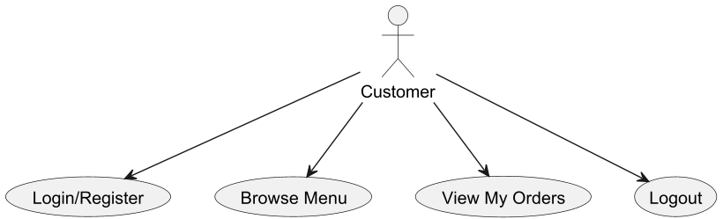

Manager Role:

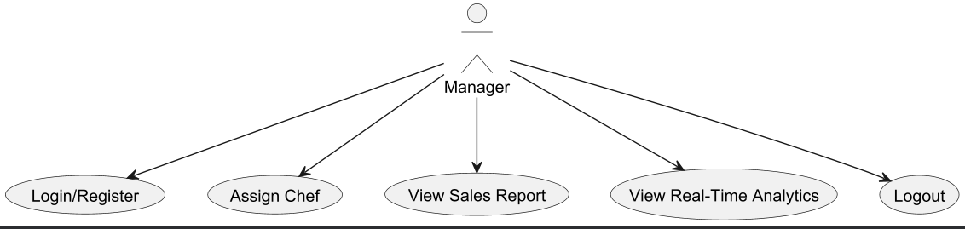

Chef Role:

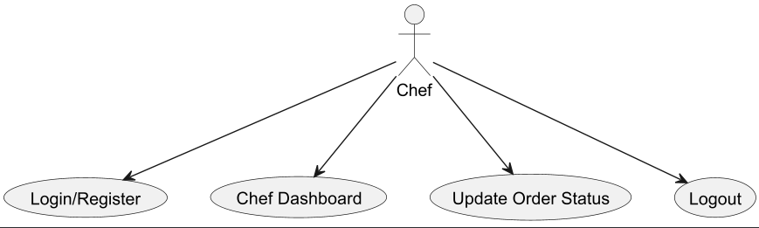
ER Diagram
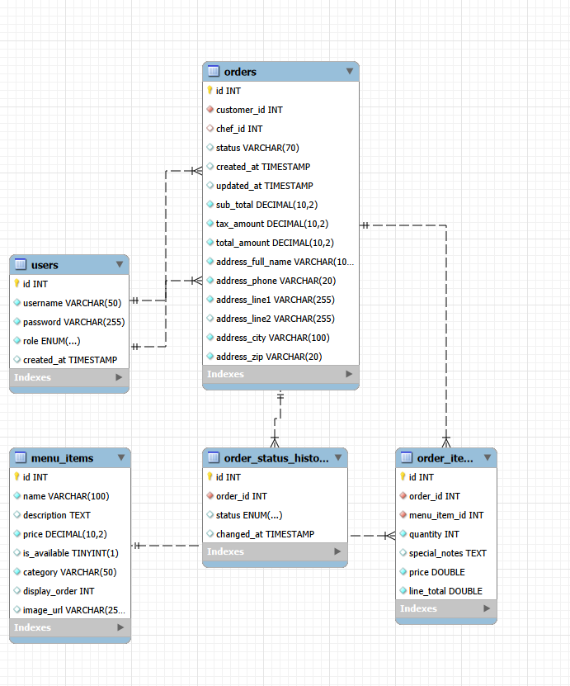

Class Diagram / UML Diagram
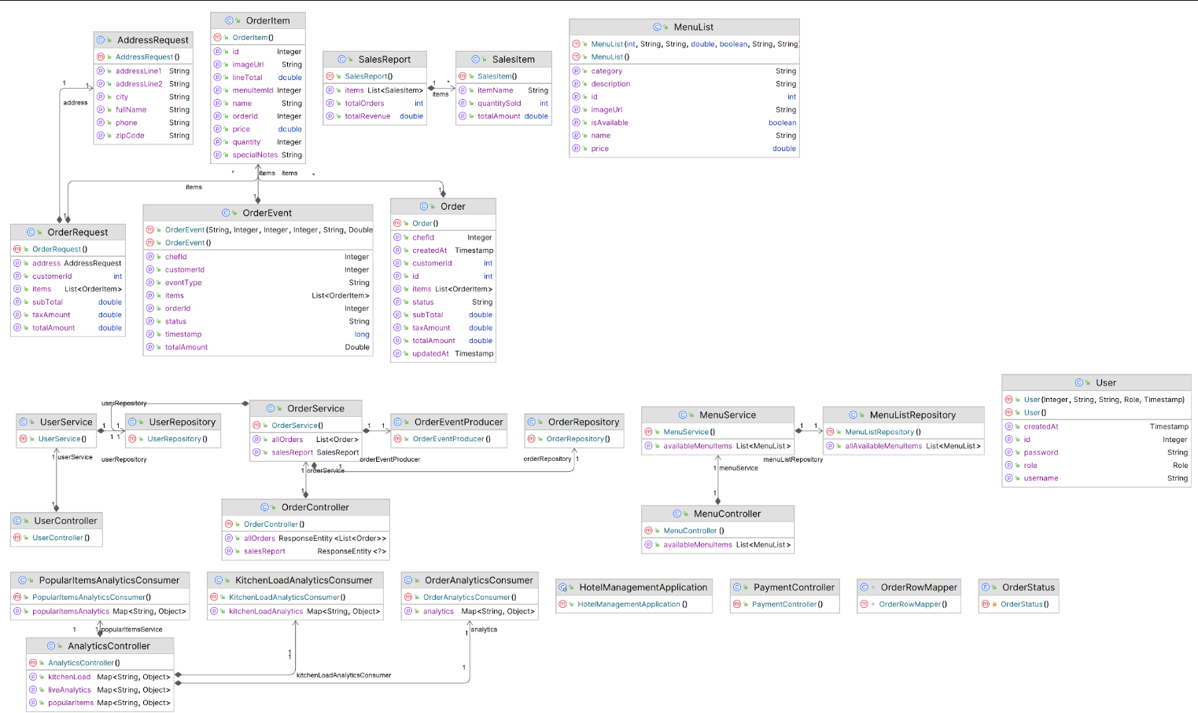

Data Flow Diagram
Level 0:

The Level 0 DFD provides a high-level overview of the system and interactions with external entities (Customer, Manager, Chef).
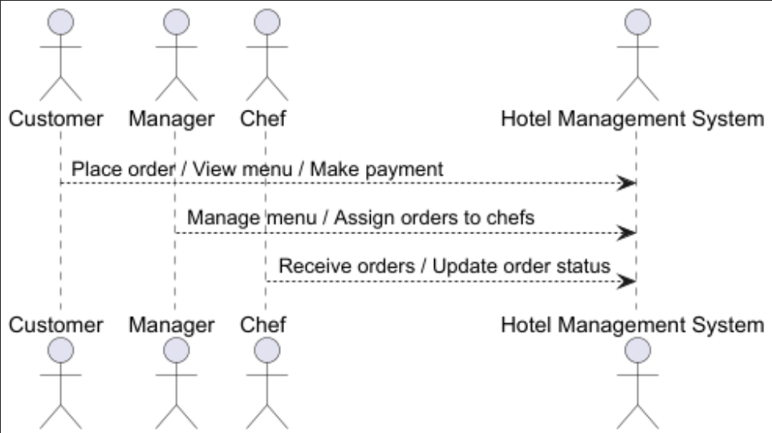

Level 1:

The Level 1 DFD decomposes the system into sub-processes for each role, showing how data flows between processes and data stores.

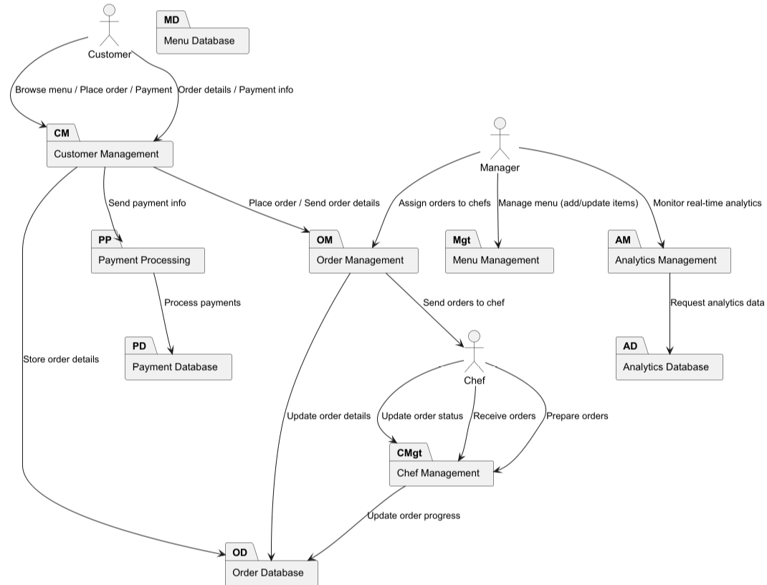

Level 2:

Due to long size have split the image into two parts.
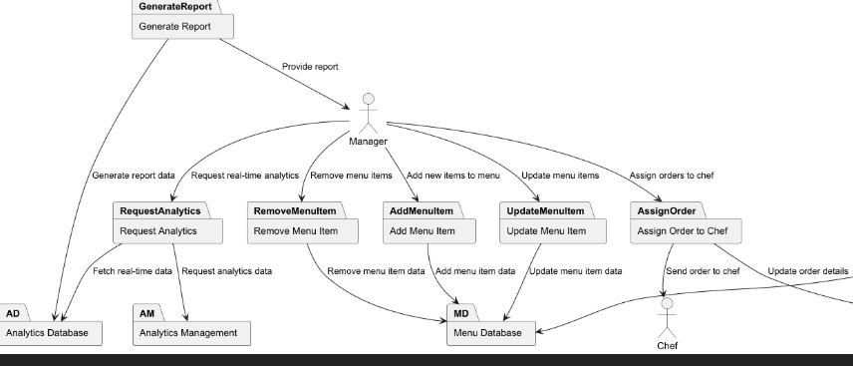

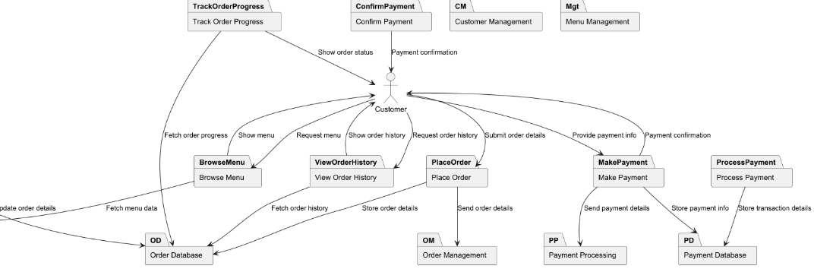

Web Pages

Home Page:

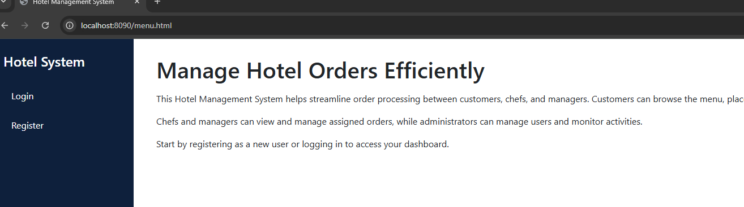
Login Screen: They can provide their username and password
- Step 1: The user opens the login screen.
- Step 2: They enter their username and password.
- Step 3: Upon clicking "Login", the system authenticates the credentials.
  - If the credentials are valid, the user is directed to their respective dashboard based on their role (Manager, Chef, or Customer).
  - If the credentials are invalid, an error message appears, prompting the user to retry.

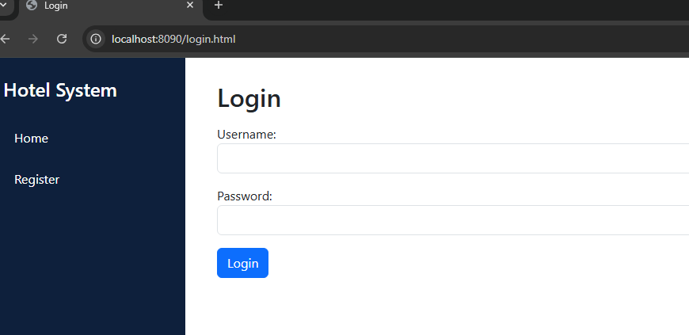
Register Screen:

User can provide username password and Role
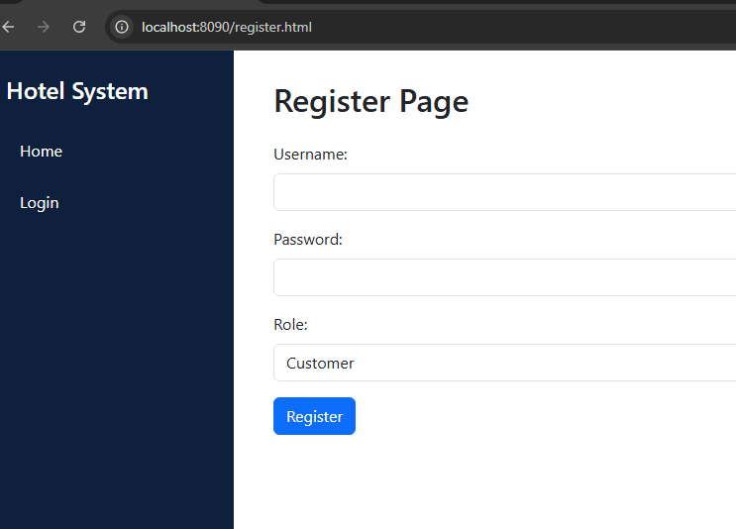

Customer Screen:
Once Customer logged in they can see below option’s
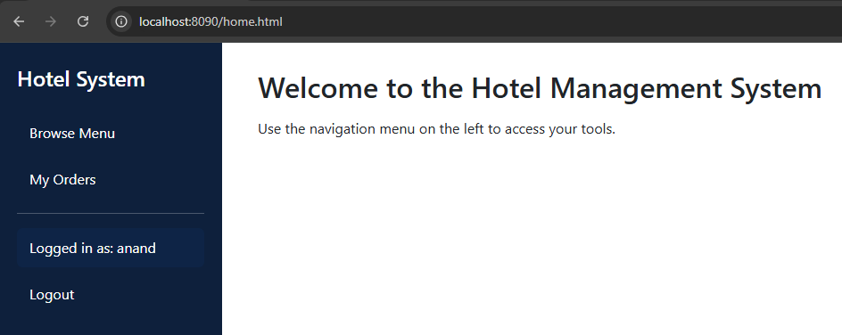
Upon click to browse menu they can see the items with menu details and price. also, they can click on Add to cart.
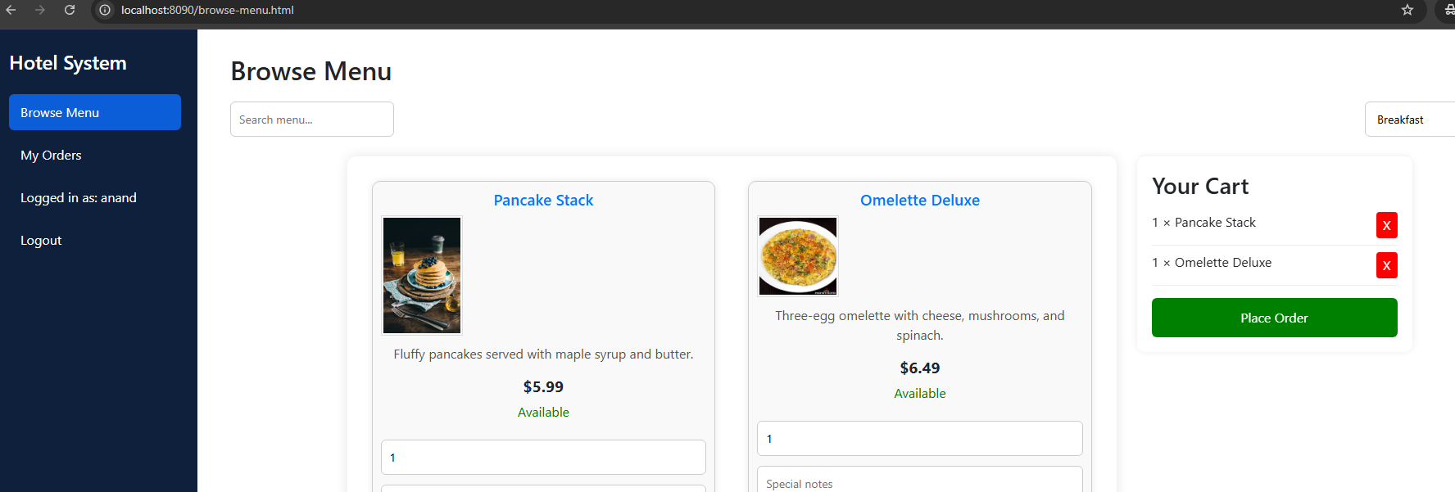
Once we place the order we will land to payment and address screen

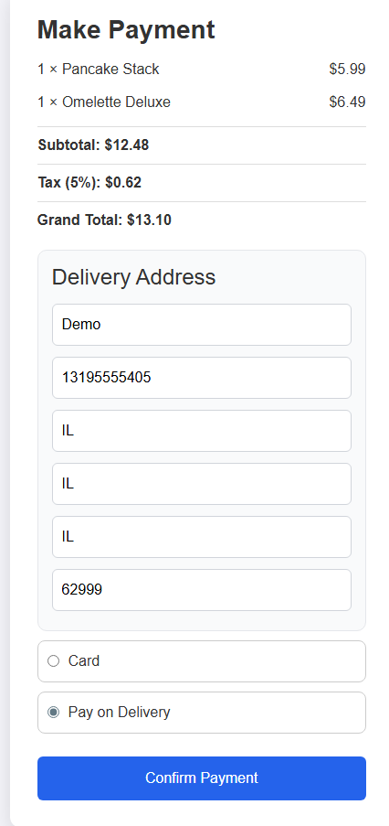

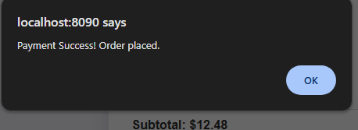

Also, on click of OK Button, we will redirect to my orders page wherein we can
A. Print the order.
B. Cancel the order if it is OPEN.
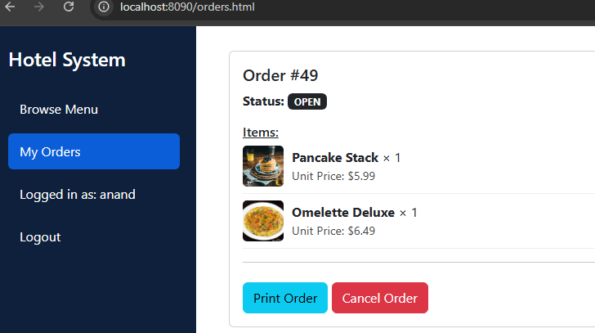

If we click on Print Order this is how screen looks like
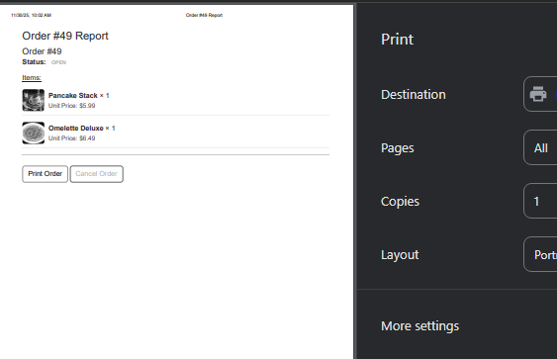

In addition, once users click on cancel Button they can see popup like below
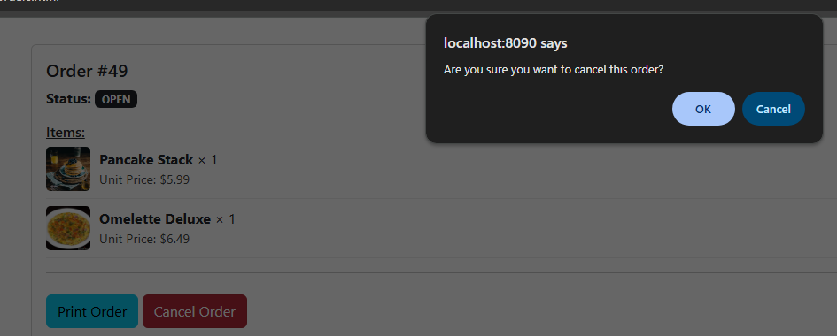
and once they click OK, order will be cancelled.
Last option would be logout once they press that button and it will invalidate current user session.
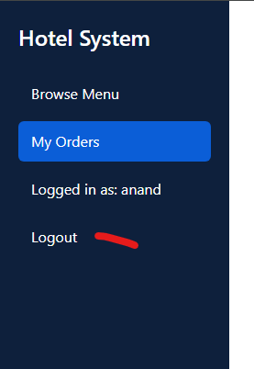

Manager Role:

Once Manager logged in, they can see following options
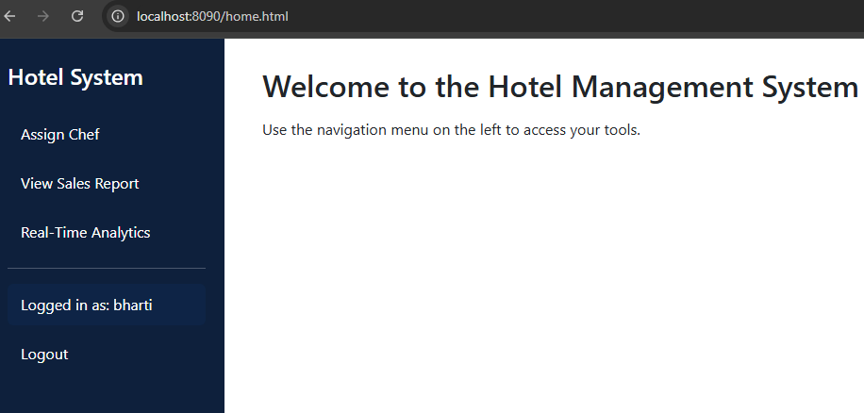

Once Manager clicks on Assign Chef, they can see order details and the CHEF drops down to which they need to assign order to prepare.
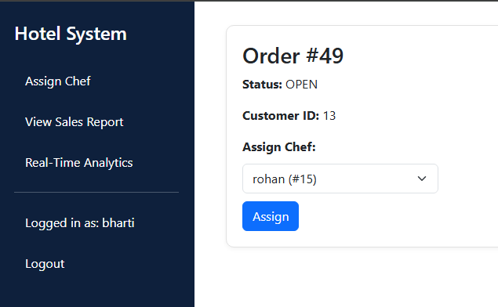
Here I have selected Rohan as CHEF and should be clicking on Assign button and we can see the message like this
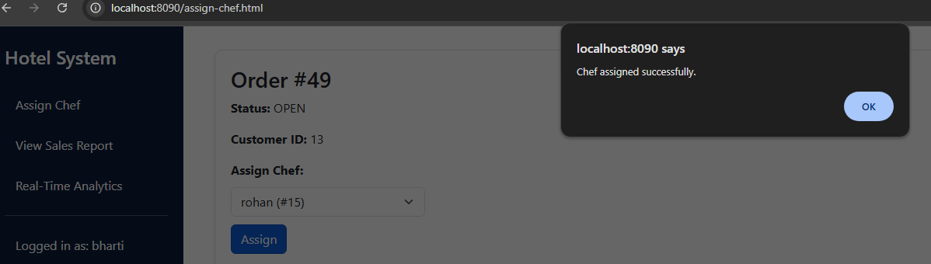
Manager will have another option like the View sales report, which will include the numbers of orders made along with price and quantity.
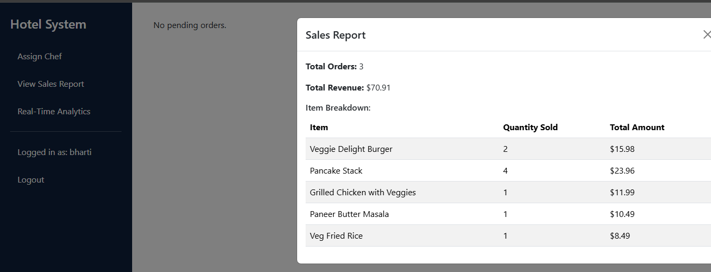

They do also have an option to see Real-time analytics to these details. it’s more like real time data using Kafka
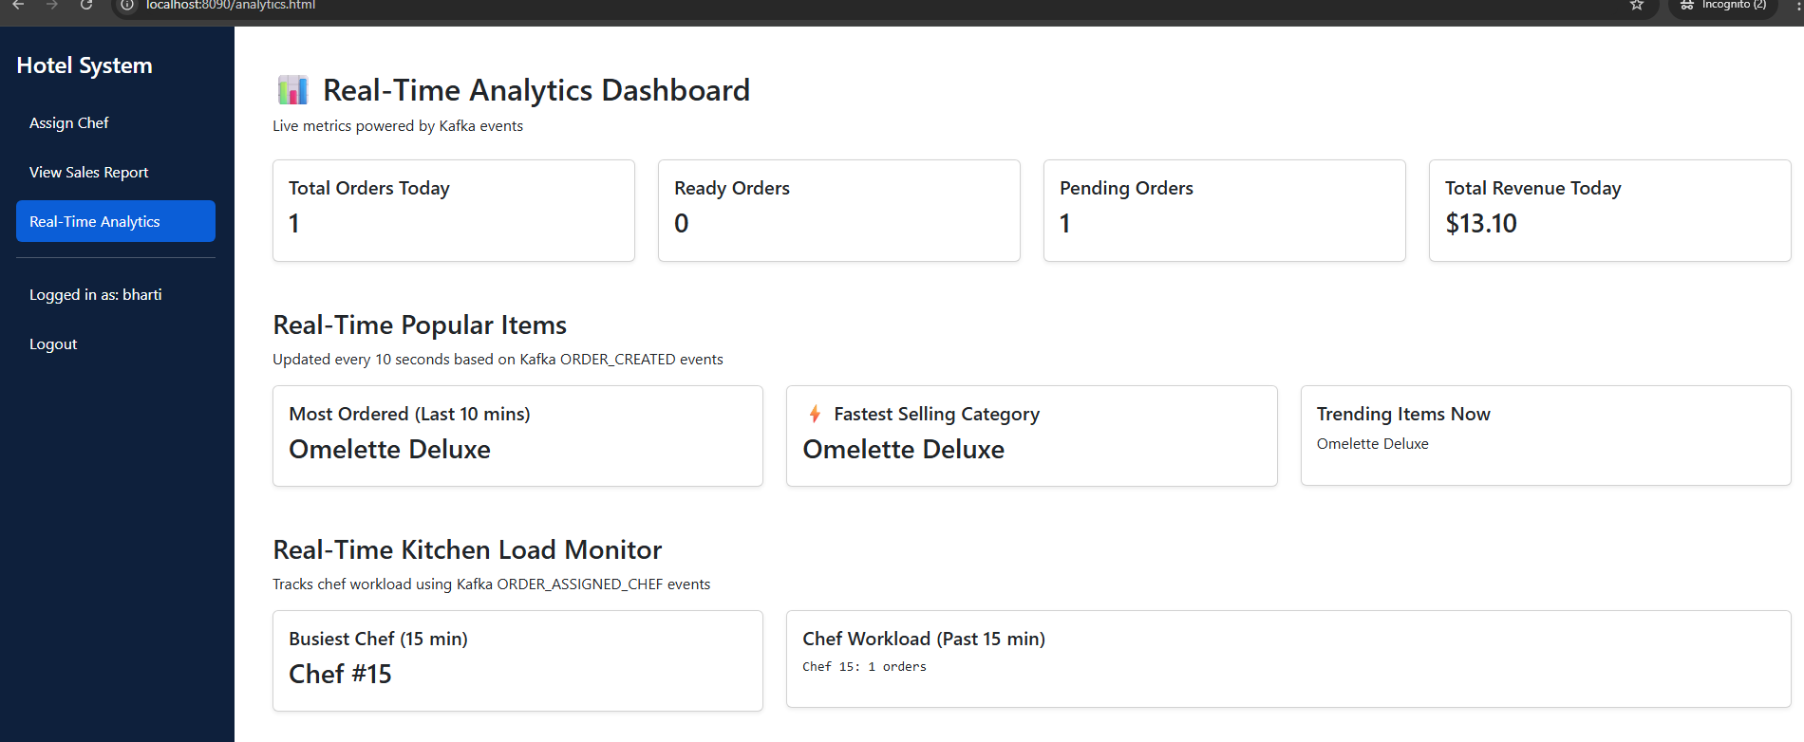

Chef Role:
Once Chef logged in they can see the option below where in CHEF can see the order assigned to them also they can change the status once it is ready to Pick up by Customer.
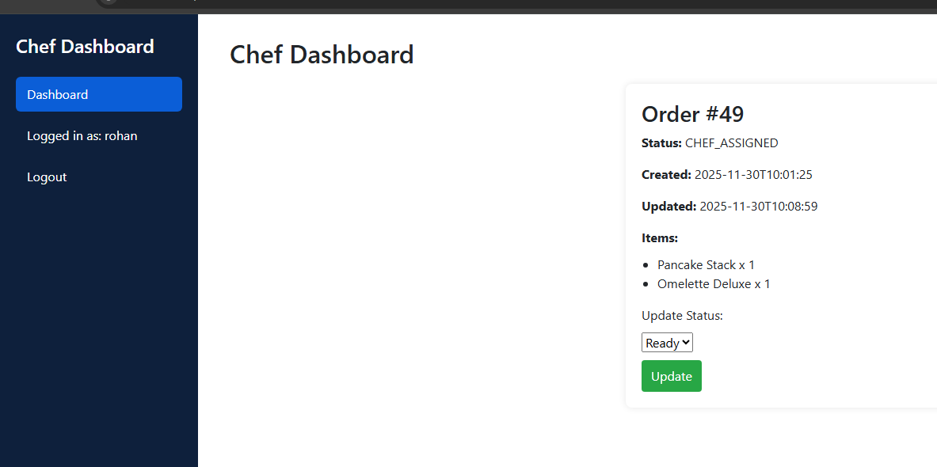
For this order I have marked this order as ready so now customers can see pickup location for the order which needs to be picked up.
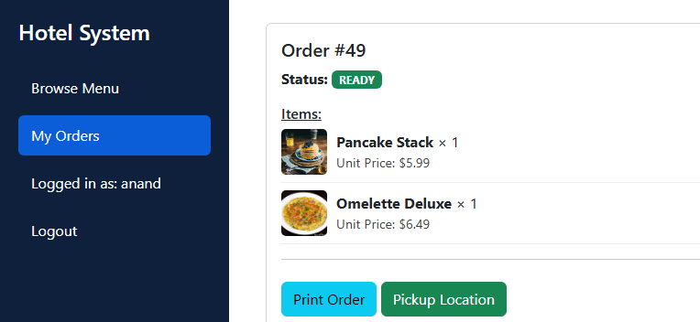
Click on Pickup location it contains fake tracking image.
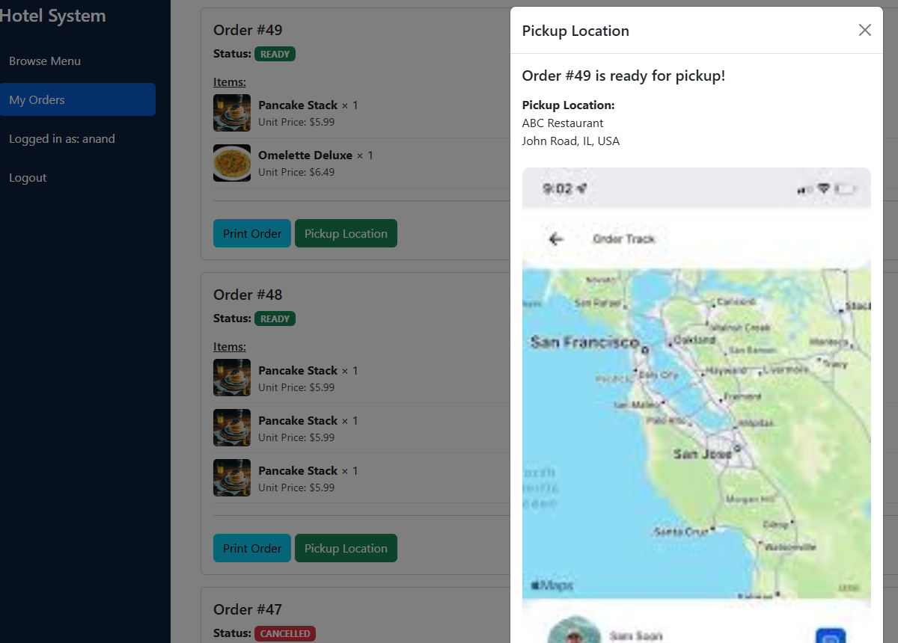

Conclusion
The Hotel Management System was developed as a comprehensive digital solution to streamline and optimize the operations of a hotel or restaurant.
The platform successfully integrates the essential functionalities required to manage customer orders, kitchen tasks, and overall restaurant management in a unified, user-friendly environment. By implementing role-based access control and dedicated dashboards for customers, managers, and chefs, the system ensures that critical operations such as order placement, menu management, and kitchen coordination are carried out efficiently, securely, and in real time.
This project addresses several challenges present in traditional hotel and restaurant management systems, such as inefficient order handling, lack of real-time data, and communication gaps between staff. By digitizing key processes like order management, payment processing, and kitchen load monitoring, the system reduces errors, speeds up workflows, and enhances collaboration between customers, staff, and managers.
Customers benefit from an intuitive ordering system and real-time order tracking, while managers can oversee operations, analyze performance metrics, and ensure smooth kitchen operations. Chefs are empowered to track orders and update their statuses, improving kitchen efficiency.
The development utilized a modern tech stack, including Java 21, Spring Boot, MySQL, and Bootstrap, providing a robust, scalable foundation for the system. The system architecture was designed with principles of modularity, scalability, and secure data handling. Role-specific modules—such as customer order management, chef assignment, and manager dashboard—were built with usability and maintainability in mind.
Additionally, tools like UML diagrams and detailed system documentation helped guide the design and development process.
Throughout the project, challenges related to data synchronization, real-time updates, and ensuring a seamless user experience across multiple roles were encountered. Ensuring smooth interaction between customer orders, kitchen staff, and managers require precise backend logic and efficient real-time data processing. Another challenge was designing secure, intuitive user interfaces that cater to the needs of each role while maintaining data integrity.
Despite these challenges, the system meets all functional requirements and demonstrates strong reliability. It is flexible enough to accommodate future enhancements, such as mobile app integration, advanced analytics, or additional real-time features. The modular nature of the system ensures that new functionalities can be integrated with minimal disruption to existing operations.
In conclusion, the Hotel Management System provides a scalable, secure, and efficient solution for managing hotel and restaurant operations. It enhances operational efficiency, streamlines communication, and improves customer experience. With ongoing development and user adoption, the system has the potential to become an essential tool for modernizing hotel and restaurant management, ultimately improving service quality, reducing errors, and optimizing workflows.

